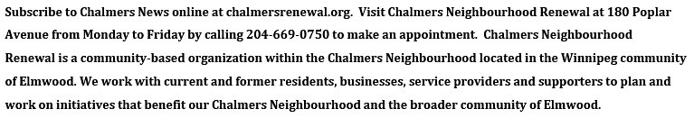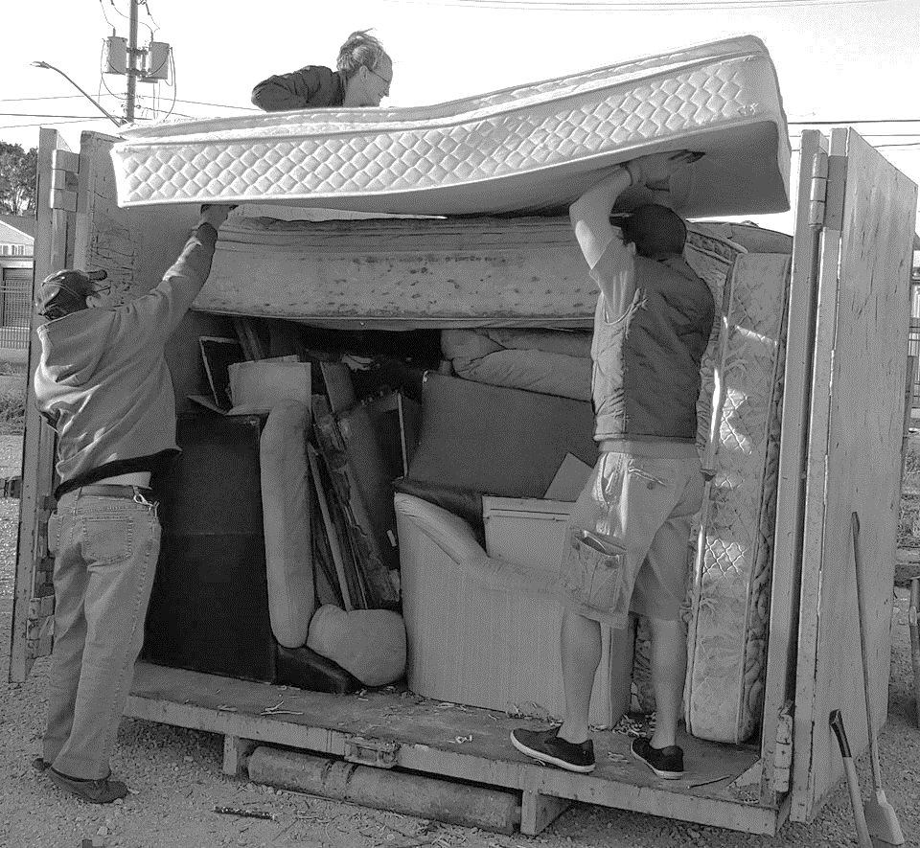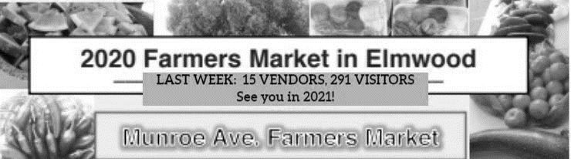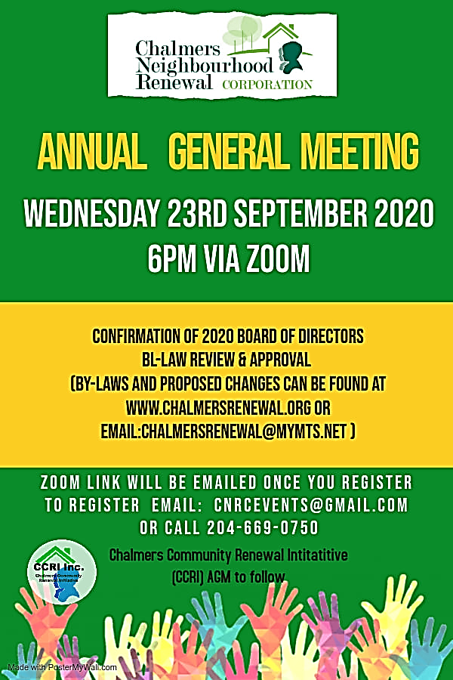

SEPTEMBER 2020

EDITION 55.0

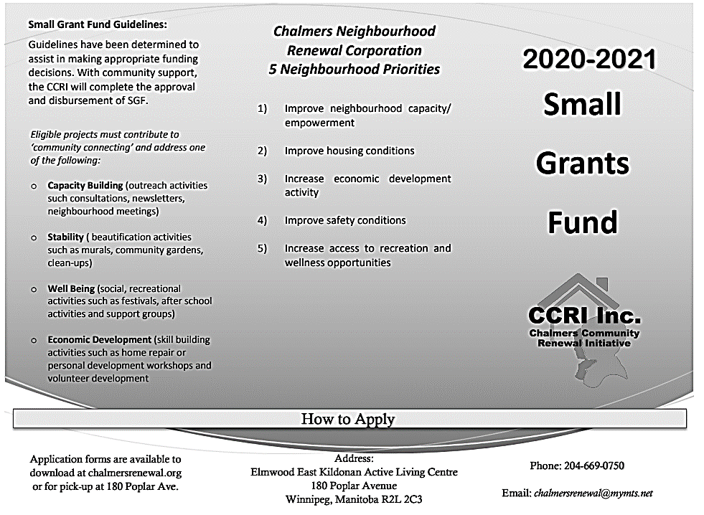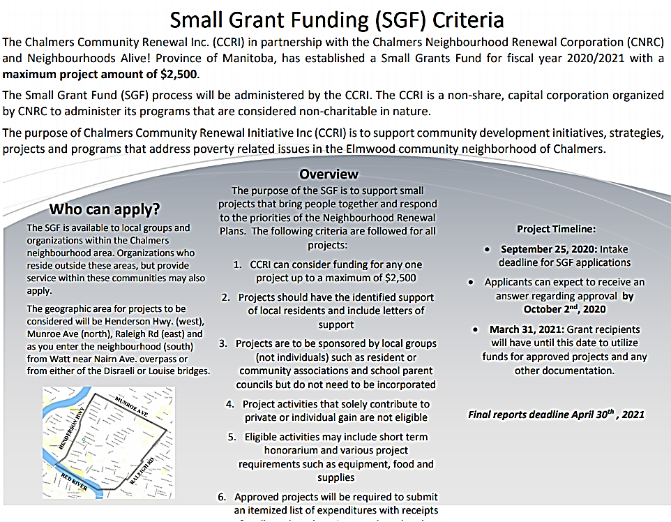

**13 RentSmart** Basics grads **this summer! Watch for our next session in October!** 

**Call 204-333-9867 to register.**

**BULKY WASTE DROP OFF, SEPTEMBER 8 & 9**

**WOW! THANK YOU to all 23 Chalmers participants and our stellar**

**volunteers Chris and Shelley for their help toward a Cleaner Chalmers.**

**Special thanks to Donoso on Bowman Avenue who picked up and**

**brought his four senior neighbours' bulky waste as well as his own!**

**Chalmers is a super friendly neighbourly 'hood!**

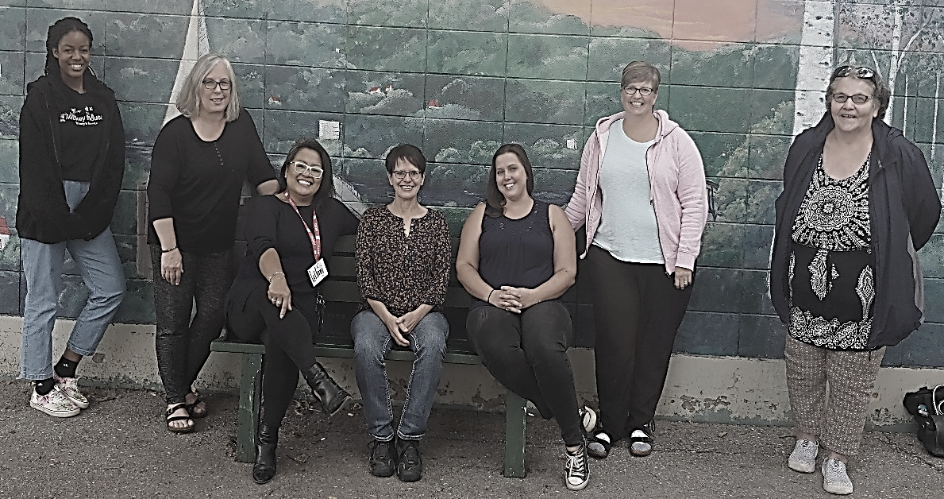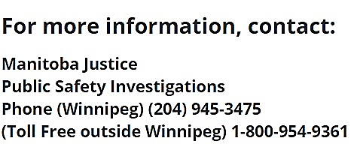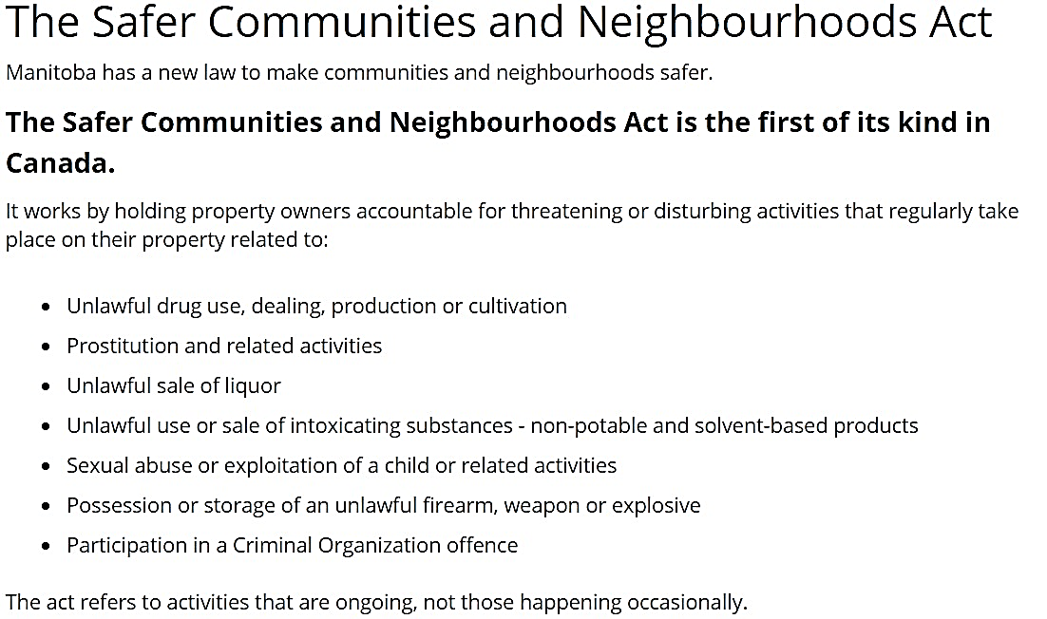

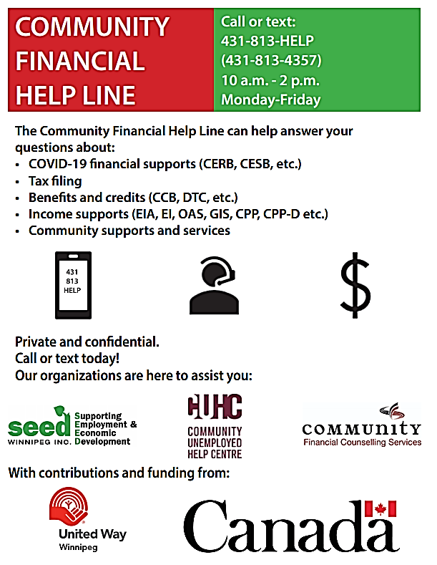

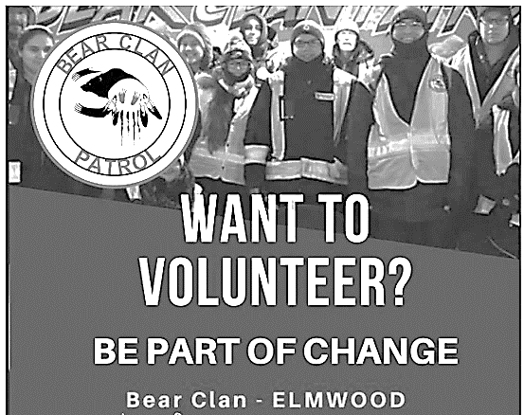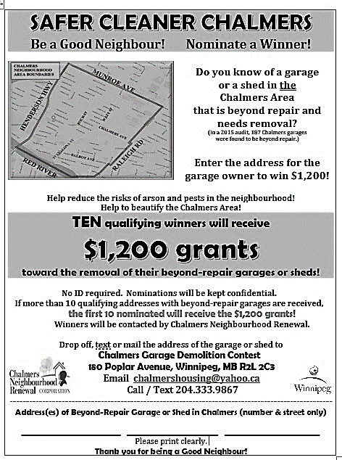

BEAR CLAN ELMWOOD

IS WALKING

on Tuesdays & Saturdays from 6-9 PM.

Meet 5:30 PM at 180 Poplar Avenue.

For more information,

call Melissa Stevenson at **204-881-2729.**





**Meet our**

**180 POPLAR STAFF! from left to right:**

**Kel, Jacquie, Leilani, Liz,**

**Charity, Janice, Sandra**

**WELCOME TO LEILANI as our new Chalmers Neighbourhood Renewal Executive Director!**