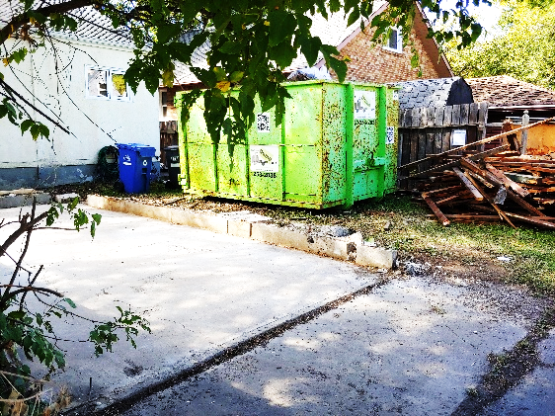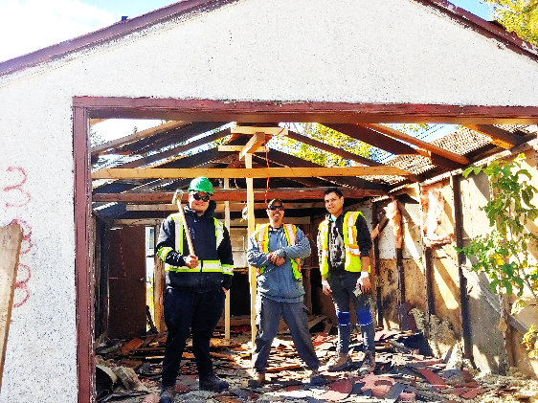

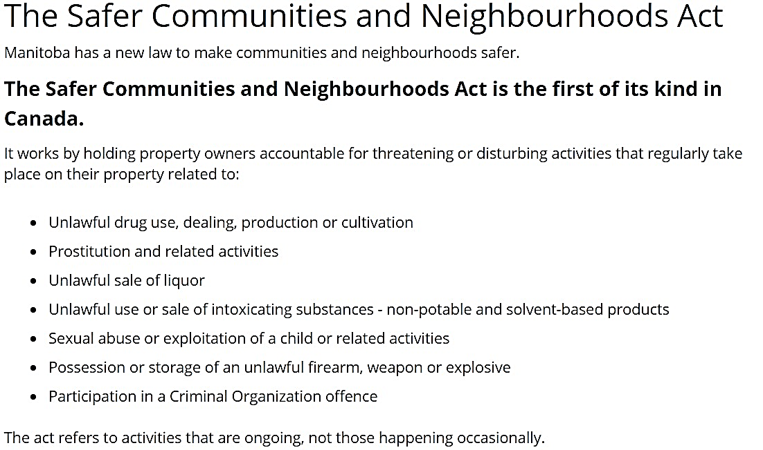



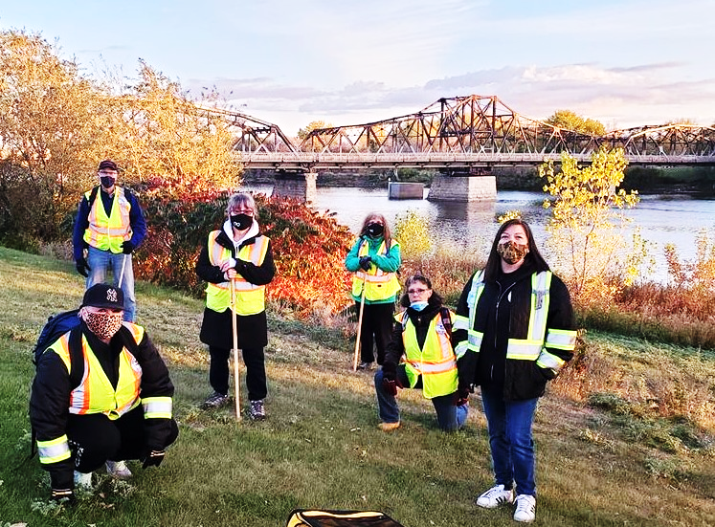

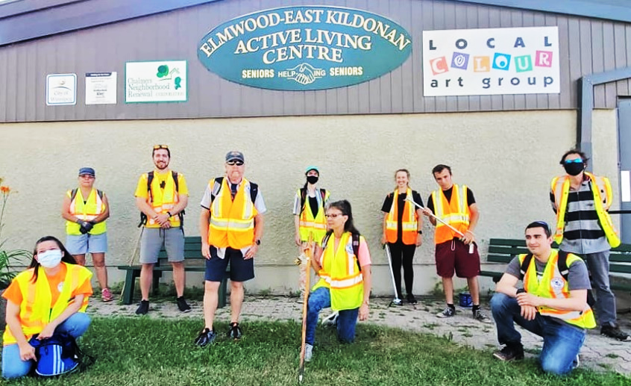



BEAR CLAN ELMWOOD IS WALKING

on Tuesdays & Saturdays from 6-9 PM. Meet 5:30 PM at 180 Poplar Avenue. For more information, call

Melissa at **204-881-2729.**

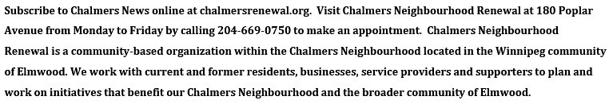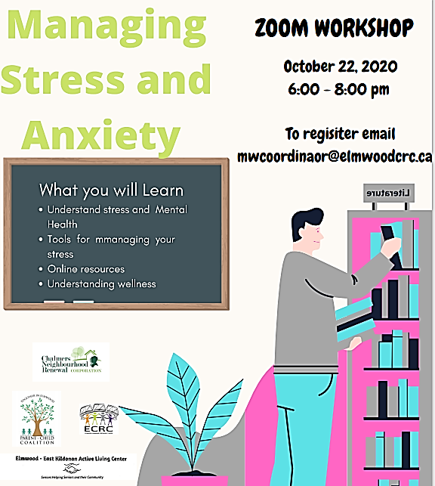 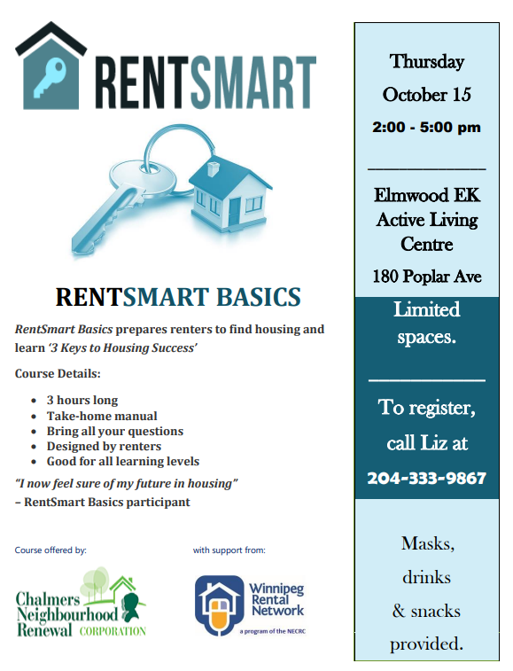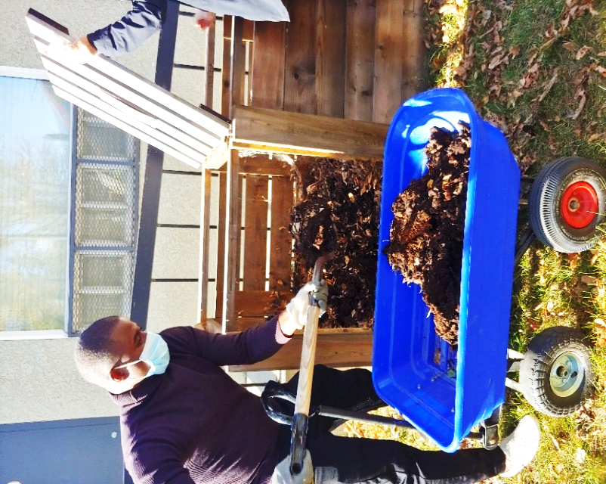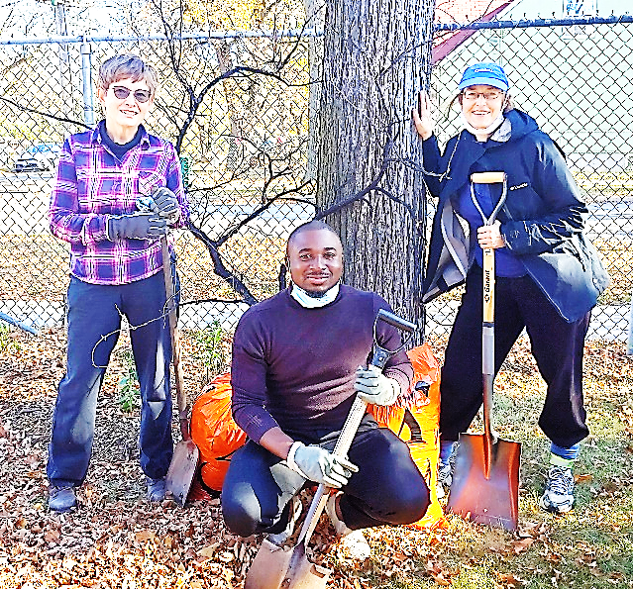

**The Elmwood Kildonan Active Living Centre would like to ensure that the health and safety of everyone who enters. Starting September 28th 2020, everyone entering into the facility will be required to wear a mask and go through a series of screening protocols. Screening protocols include the sanitization of hands, a temperature check, and a series of standard COVID-19 related questions. Once in the Centre, the 6-feet social distancing protocol will be enforced. We hope that all the new measures taking place will help stop the spread of the COVID-19 virus.**

**Beautifying Chalmers:** **Thank you** so much to Debbie and the “Branching Out” Master Gardeners Study group for donated plants and time, and Maureen our Master Composter from Green Action Centre and Kiza from the neighbourhood for working so hard to replace weeds with perennials at 180 Poplar. Looking forward to Spring!

OCTOBER 2020

EDITION 56.0